TUGAS SHELL LINUX

“Disusun dalam rangka memenuhi salah satu tugas kelompok pada mata kuliah Sistem Operasi Oleh Dosen Candrasena Setiadi, ST., M.MT”



**Disusun oleh:**

**Muhammad Ammar Hafizh (2341720074)**

**JURUSAN TEKNOLOGI INFORMASI**

**PRODI D-IV TEKNIK INFORMATIKA**

**POLITEKNIK NEGERI MALANG**

**2024**

**Pemrograman bash shell pada system operasi linux**

$ Lakukan perintah berikut: $

* **WHO**

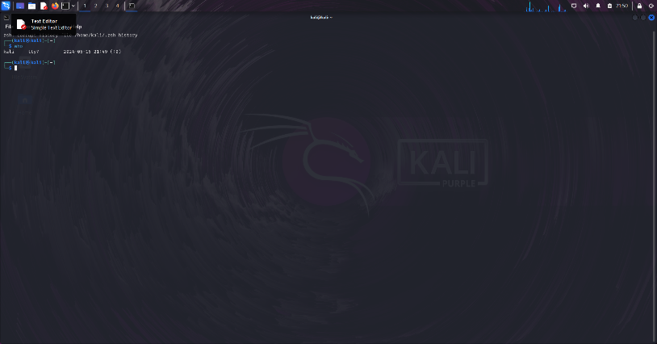

* **WHOAMI**

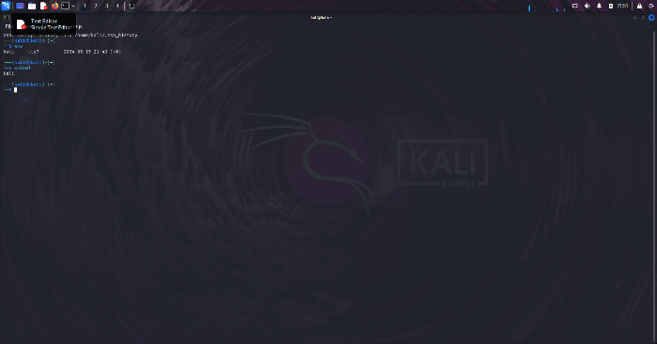

* **LS**

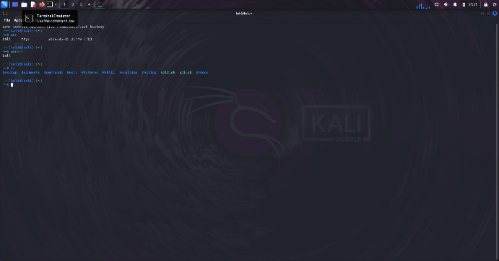

* **MKDIR TESTING**

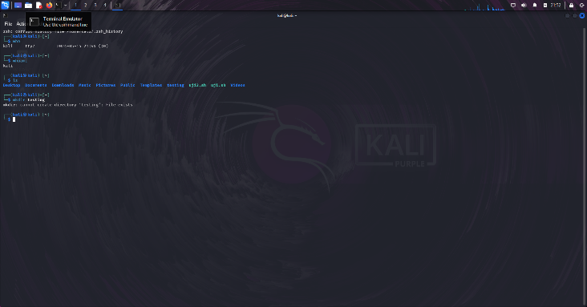

* **SUDO SU**



* **MKDIR TESTING**

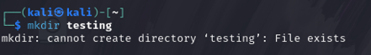

* **CD TESTING**

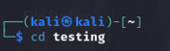

* **TOUCH INDEX.JS**

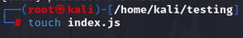

* **LS**

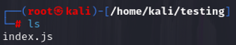

* **CD ..**

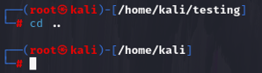

* **LS**



* **CLEAR**

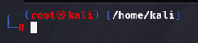

* **RM –RF TESTING\***

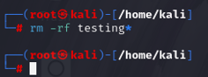

$ Langkah pemrograman shell: $

* **nano uji.sh**

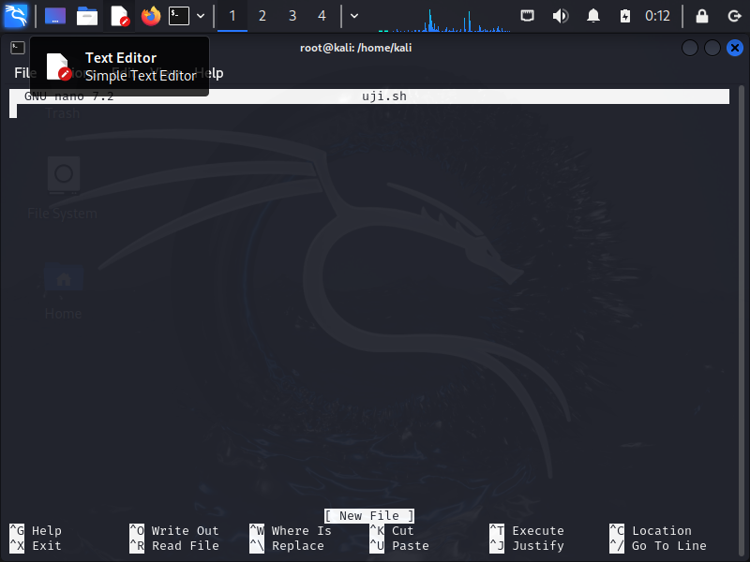

* **#!/bin/bash**

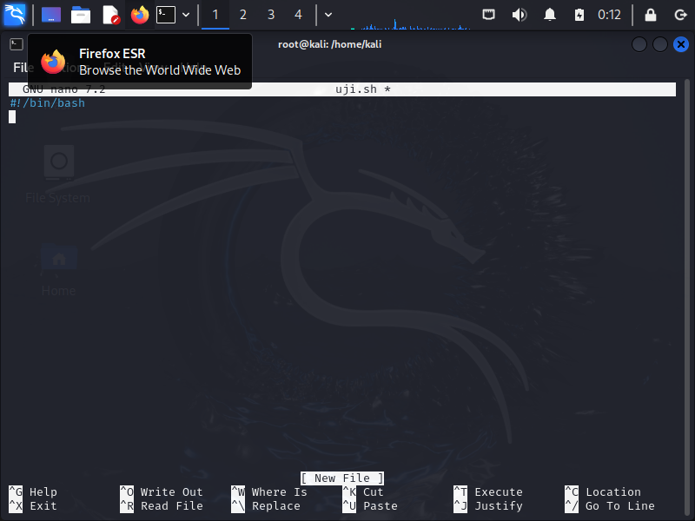

* **echo “saya super admin”**

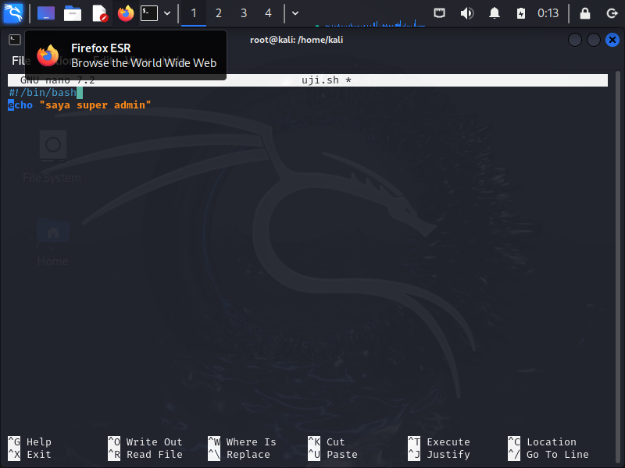

* **^x**

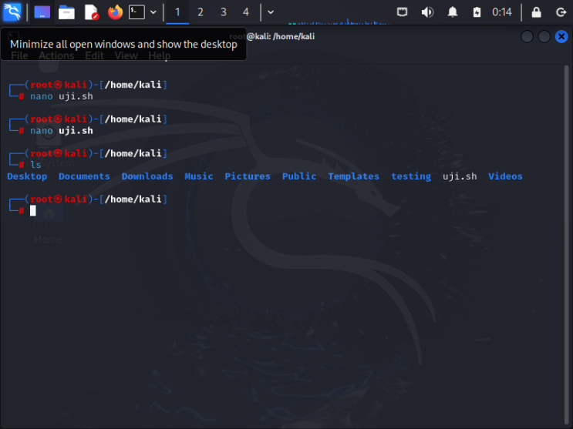

* **Y**

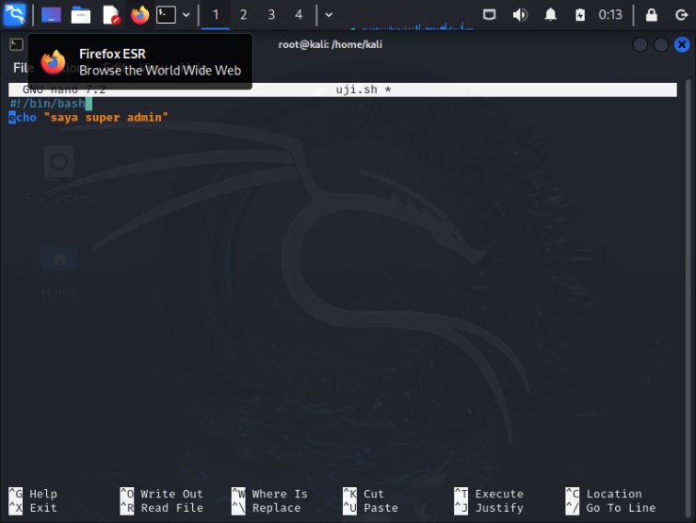

* **Ls**

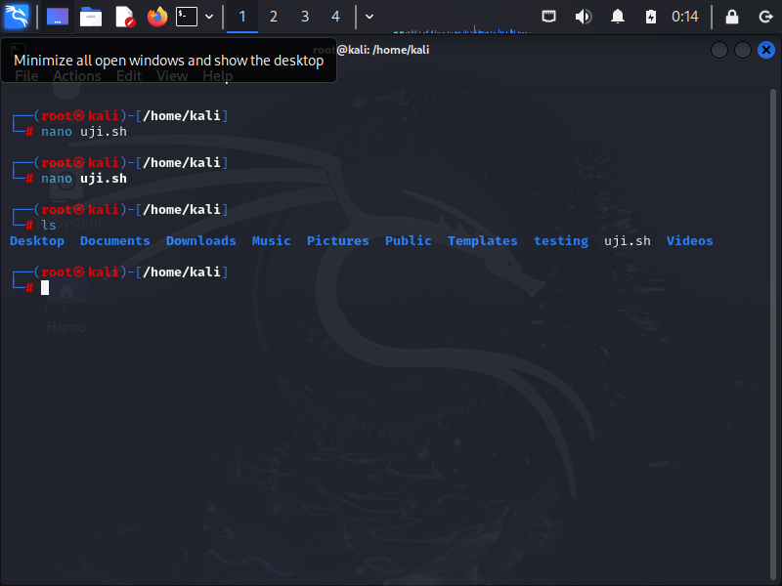

* **ls –l uji.sh**

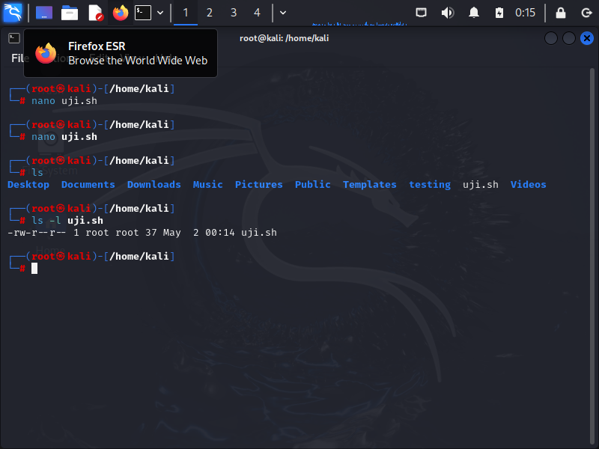

* **chmod +x uji.sh**

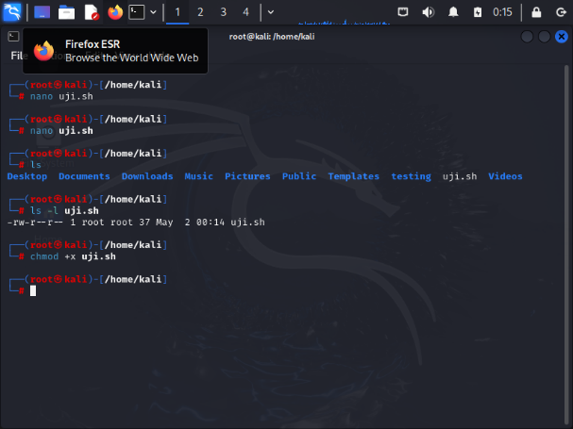

* **./uji.sh**

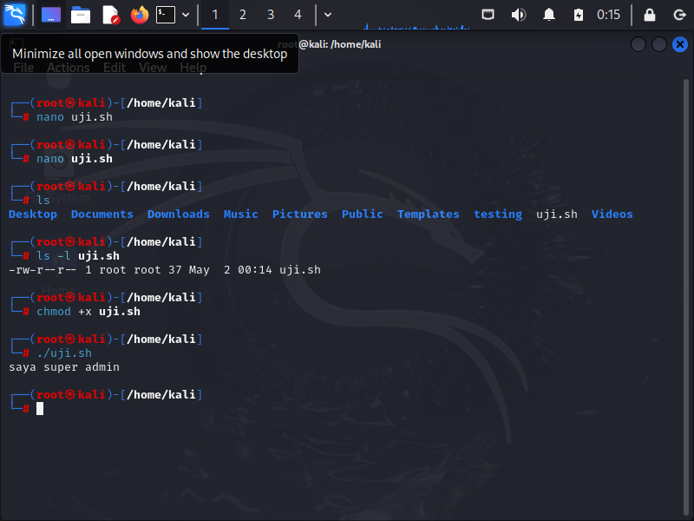

$ File sederhana $

**• nano uji2.sh**

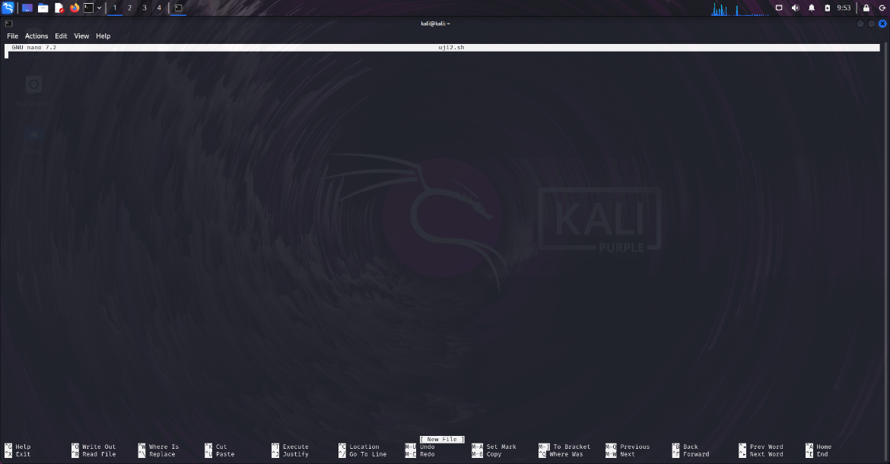

**• #!/bin/bash**

**• #Program shell**

**• #**

**• var1=y**

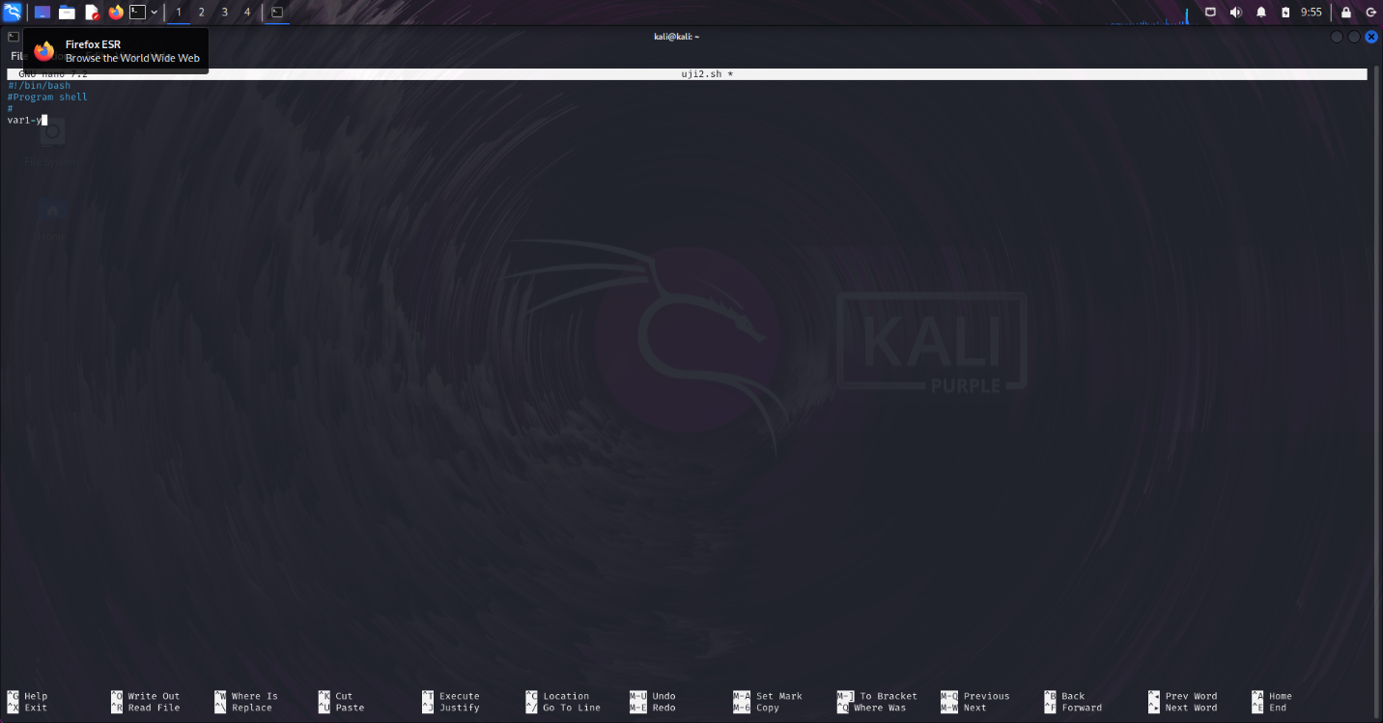

**• ^x**

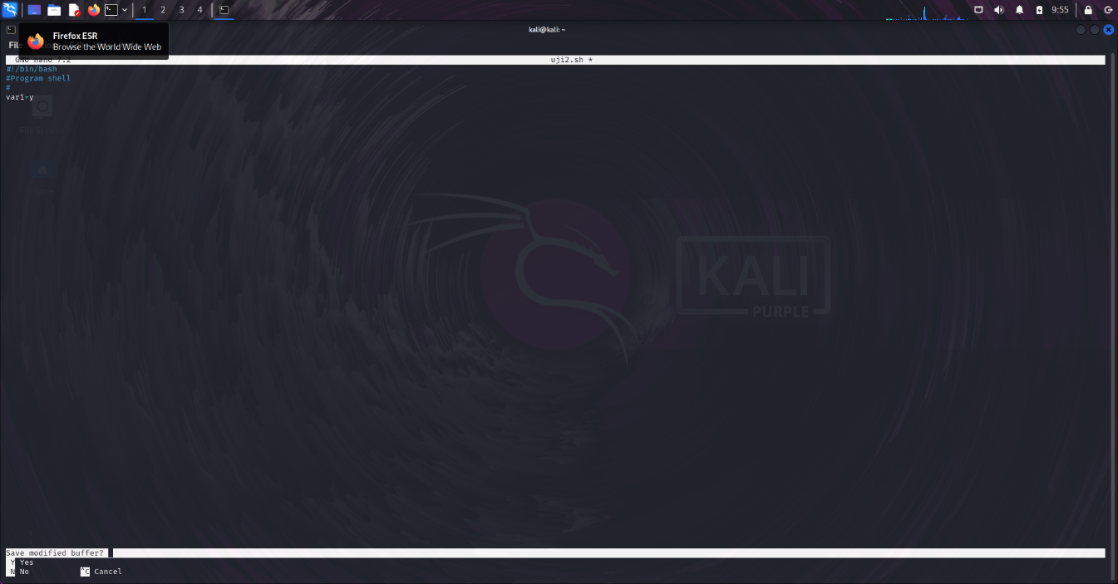

**• Y**

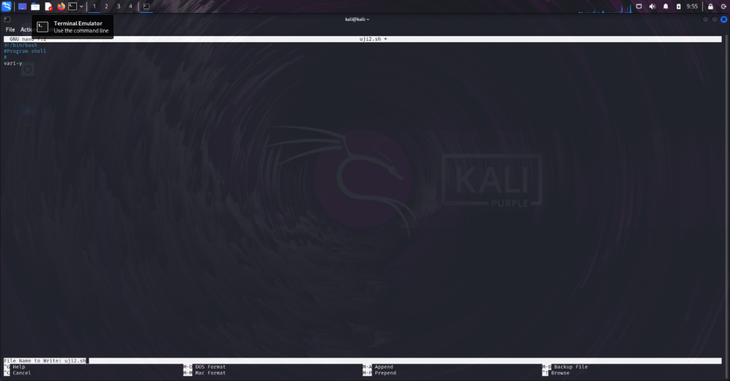

**• echo $var1**

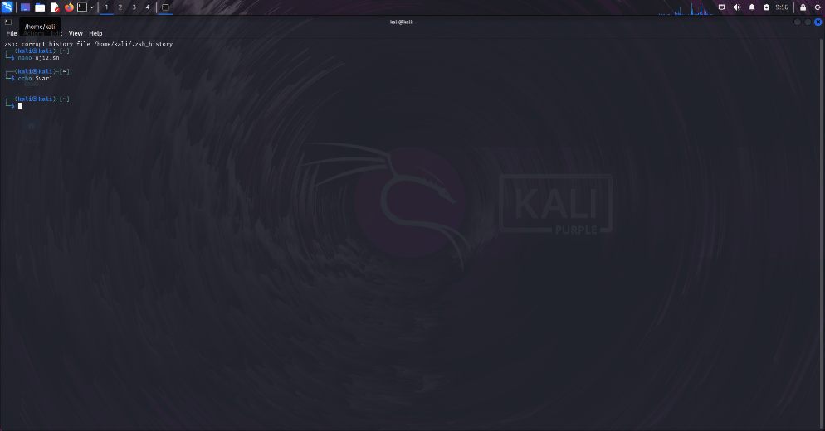

**• chmod +x uji2.sh**

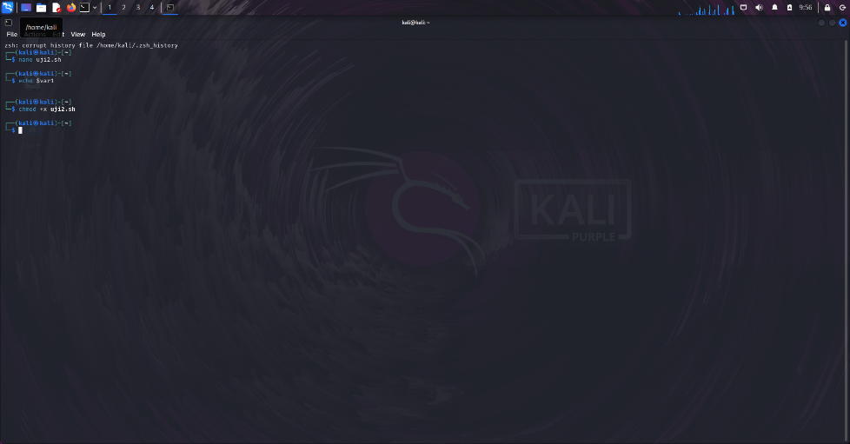

**• ./uji2.sh**

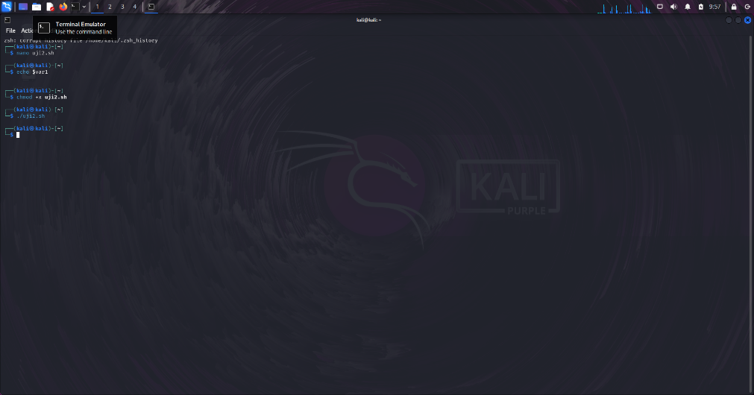

$ shell interaktif 1 $

* **VPT=VAR1=Y**

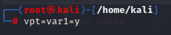

* **ECHO $VPT**

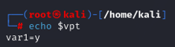

$ shell interaktif 2 $

* **V1=2**



* **V2=’+’**

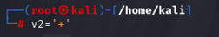

* **V3=5**

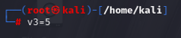

* **V4=’=’**

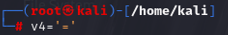

* **V5=7**

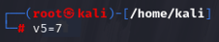

* **V6=$V1$V2$V3$V4$V5**

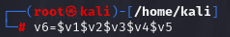

* **ECHO V6**

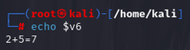

$ Read string $

* **READ JENIS**

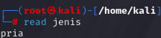

* **PRIA**

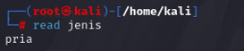

* **ECHO $JENIS**

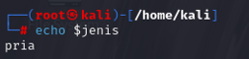

$ Penjumlahan aritmatik $

* **NANO ARITMATIK.SH**

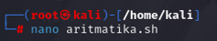

* **#!/BIN/BASH**



* **A=17**



* **B=3**



* **LET RESULT=$A+$B;**



* **ECHO “$RESULT”**



* **^X**

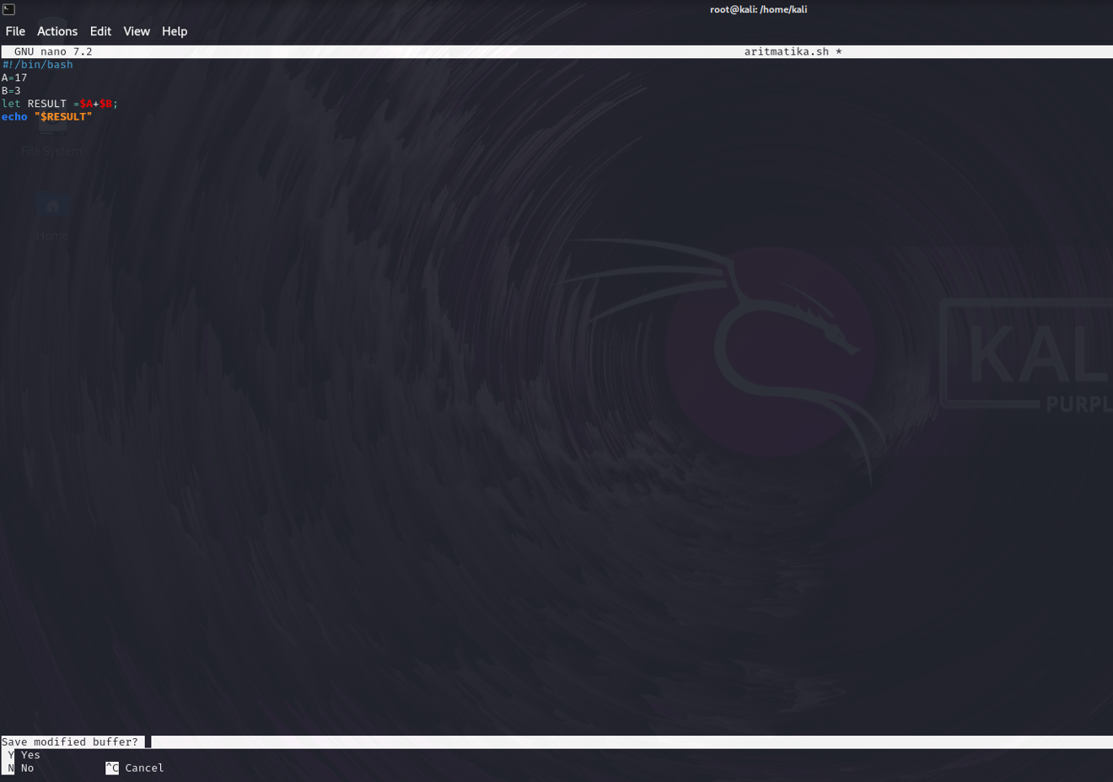

* **Y**

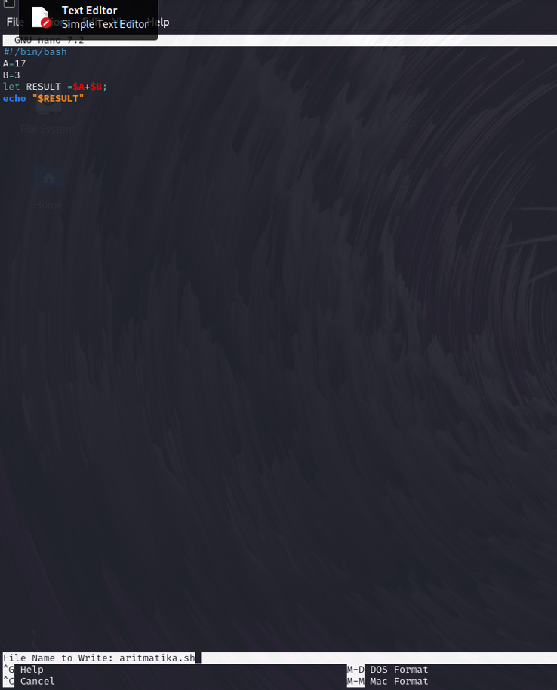

* **CHMOD +X ARITMATIK.SH**

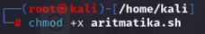

* **./ARITMATIK.SH**

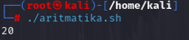

$ .js $

* **NANO CODE.JS**

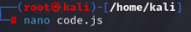

* **CONST DATA = “SAYA SUPER ADMIN”**

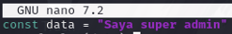

* **CONSOLE.LOG(DATA);**



* **^X**

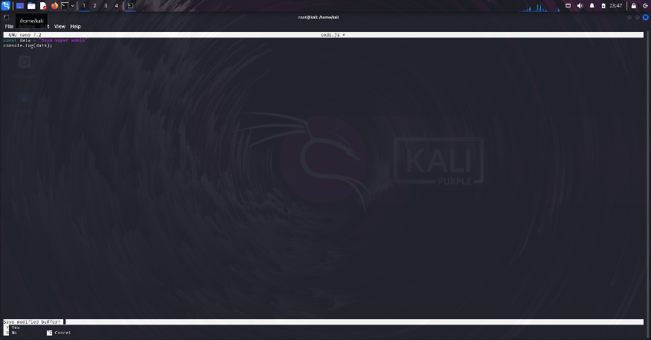

* **Y**

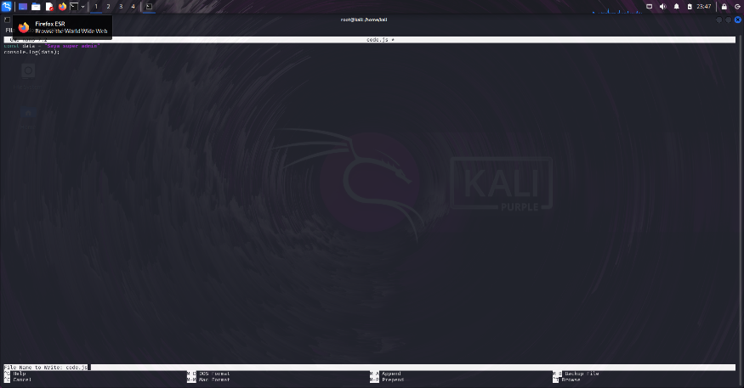

* **CAT CODE.JS**

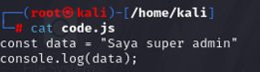

* **NODE CODE.JS**

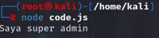

$ Install $

* **APT INSTALL NODEJS**

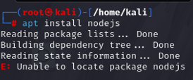

* **APT UPDATE**

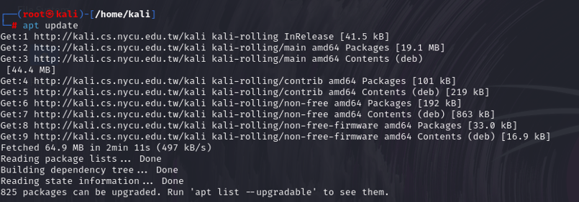

* **APT UPGRADE**

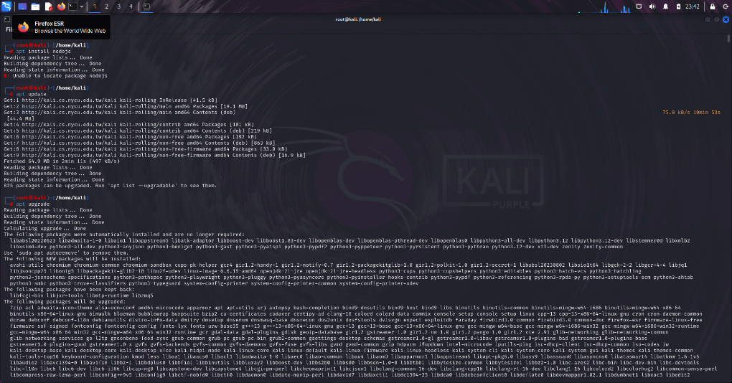

* **NODE CODE.JS**

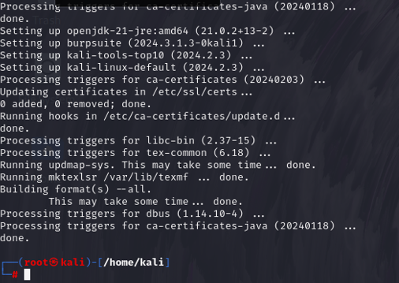

$ World wide web and get http https (wget) $

* **WGET** <https://drive.google.com/file/d/1kQwK1fjfbBkC4WQKhOmv4IiJ3b22i3D_/view?usp=drive_link>

<http://192.168.73.195/File-SisOp.zip>

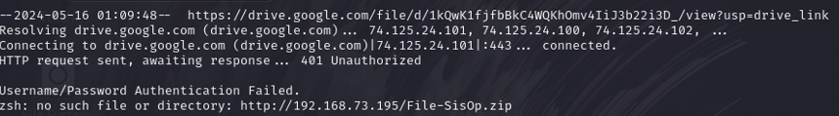

* **SUDO APT INSTALL WGET**

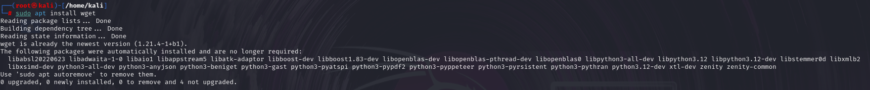

$ Condition shell pada linux $

* **#!/BIN/BASH**

**TMER=10**

**WHILE [ $TMER –GT 0 ]**

**DO**

**ECHO “… $TMER”**

**TMER=$((TMER -1))**

**SLEEP 10S**

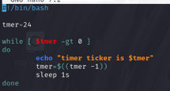

* **DONE**

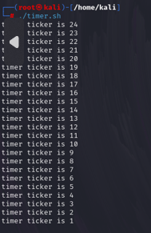

* **Code**

**#!/bin/bash**

**tmer=24**

**while [ $tmer -gt 0 ]**

**do**

**echo "timer ticker is $tmer"**

**tmer=$((tmer -1))**

**sleep 1s**

**done**

$ Pemrograman condition shell $

* **CLEAR**

**ECHO “STOK BARANG HARI INI”;**

**ECHO “…………………………….”;**

**ECHO “1. BERAS”;**

**ECHO “2. GULA”;**

**ECHO “3. GARAM”;**

**ECHO “4.EXIT”;**

**READ –P *PILIH BARANG KELUAR [1-4 ] :* PIL;**

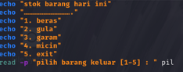

* **IF [ $PIL –EQ 1 ];**

**THEN**

**ECHO “ BANYAK BARANG = *;**

**READ JUM**

**LET BAYAR=JUM*10000;**

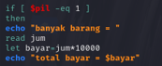

* **ELIF [ $PIL –EQ 4 ];**

**THEN**

**EXIT 0**

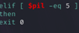

* **ELSE**

**ECHO “BARANG TIDAK TERSEDIA”**

**EXIT 1**

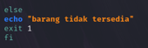

* **FI**

**ECHO “HARGA BAYAR = RP. $BAYAR”**

**ECHO “TERIMAKASIH ATAS KUNJUNGAN ANDA”**

**ECHO “ KANTIN TI”**

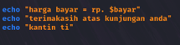

* **NANO KASIR.SH**
* **LS –L KASIR.SH**
* **CHMOD +X KASIR.SH**
* **LS –L KASIR.SH**

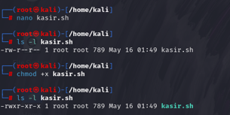

* **./KASIR.SH**

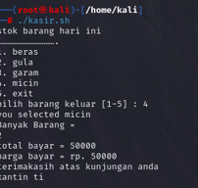

* **Code**

echo "stok barang hari ini"

echo "……………………………."

echo "1. beras"

echo "2. gula"

echo "3. garam"

echo "4. micin"

echo "5. exit"

read -p "pilih barang keluar [1-5] : " pil

if [ $pil -eq 1 ]

then

echo "you selected beras"

echo "banyak barang = "

read jum

let bayar=jum*10000

echo "total bayar = $bayar"

elif [ $pil -eq 2 ]

then

echo "you selected gula"

echo "banyak barang = "

read jum

let bayar=jum*5000

echo "total bayar = $bayar"

elif [ $pil -eq 3 ]

then

echo "you selected garam"

echo "banyak barang = "

read jum

let bayar=jum*15000

echo "total bayar = $bayar"

elif [ $pil -eq 4 ]

then

echo "you selected micin"

echo "banyak barang = "

read jum

let bayar=jum*25000

echo "total bayar = $bayar"

elif [ $pil -eq 5 ]

then

exit 0

else

echo "barang tidak tersedia"

exit 1

fi

echo "harga bayar = rp. $bayar"

echo "terimakasih atas kunjungan anda"

echo "kantin ti"